**Title [Times New Roman, Bold, 16-point Font]**

－Sub-title of the Paper if necessary [Times New Roman, Normal, 13-point Font]－

Taro Hirodai1, Jiro Kure2, Saburo Hiroshima*3 [Times New Roman, Normal, 12-point Font]

1. Professor, Graduate School of Advnaced Science and Engineering, Hiroshima University
2. Assistant Professor, Graduate School of Advenced Science and Enginnering, Hiroshima University
3. Doctoral Student, Graduate School of Advanced Science and Engineering, Hiroshima University

Email: [taro_p@team2024.hiroshima-u.ac.jp](mailto:taro_p@team2024.hiroshima-u.ac.jp) (*Speaker)

**Abstract**

A compressed and fact-based abstract should be given with 300 words. Times New Roman, Normal, 11-point Font should be used for the abstract body.

**Keywords**: At most 5 keywords should be given.

**1. Main Section**

***1.1. Subsection***

Article should be structured with main sections “Study background”, “Study method”, “Results”, “Discussions” and “Conclusions” as well as the relevant subsections. “Acknowledge” section is optional. Times New Roman, Bold, 12-point Font should be used for the heading of main sections while Times New Roman, Bold-Italic, 12-point Font should be used for the heading of subsections. There should be a line break before and after the headings.

The single-column article should be prepared with 18 mm margins for left, right, top and bottom. It should also be set 14-point line spacing. Times New Roman, Normal, 11-point Font should be used for the text body.

Figures and Tables should be presented in single or double-column as shown below. The figures and tables should be positioned near the relevenat text. Captions should be given for each figure and table with Times New Roman, Italic, 11-point Font. All the figures and tables should be centered aligned. High-resolution pictures are recommended. There should be a break line before and after the figures and tables.

*Table 1. Comparison of design sensitivity*

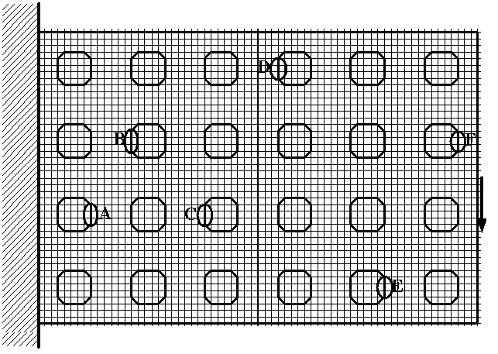 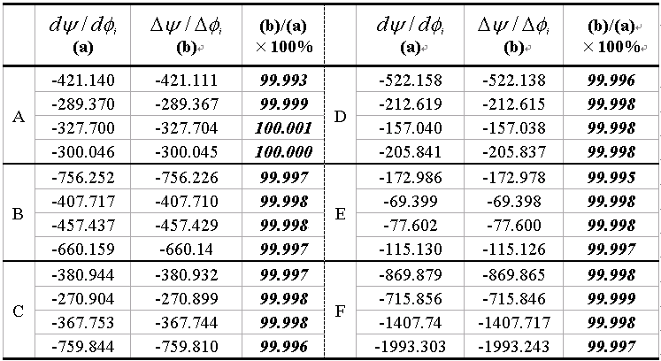

*Figure 1. Cantilever plate*

Equations should be aligned left and numbered at the right end. There should also be a line break before and after equations. A sample equation is given as follow.

 (1)

It is highly recommended that the article should be 4-8 pages. Please also ensure that the email address of the speaker is provided. The full paper manuscript should be submitted in word file version.

**References**

The references should be listed with square bracket along with the format as shown below. The references should be cited in an ascending order with the quotaion [1,2].

[1] J.A. Sethian, Level Set Methods and Fast Marching Methods: Evolving Interfaces in Computational Geometry Fluid Mechanics, Computer Vision, and Materials Science, Cambridge University Press, (1999).

[2] S. Cho, H. Jung, Design sensitivity analysis and topology optimization of displacement-loaded nonlinear structures, *Computer Methods in Applied Mechanics and Engineering*, **192**, (2003), 2539-2553.